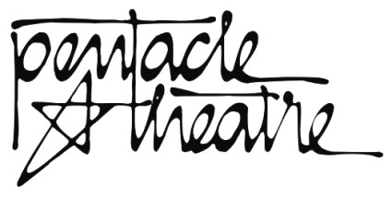
AUDITIONS

Play: Date:
Name:
Mailing Address:
City: State/ZIP:
Phone Days: Evenings:
Email Address:
Formal Training (acting, voice, dance, technical, other)

Past Experience (name of show, part played, when, where, continue on separate page if needed)

Height: Weight:
Age: Gender:
Part or parts auditioning for:
Will you take another role, if offered?
Are you available as technical support?
If so, in what capacity?
Rehearsal conflict dates:

DIRECTOR’S COMMENTS (Do not write below this line)
General comments:
Voice:
Movement:
Technical help:
Other:

TURN OVER FOR VOLUNTEER DISCLOSURE & PHOTO RELEASE
VOLUNTEER DISCLOSURE &
Photo Release Agreement for Pentacle Theatre Volunteers
Pentacle Theatre
145 Liberty St. NE
Salem, OR 97301

For those auditioning … if you are cast in a Pentacle Theatre show, here are some things the Governing Board would like you to know about Pentacle:

- Pentacle Theatre is a community, volunteer-based organization. As such, we do not pay actors, or provide reimbursement for mileage.

- Pentacle plays run for 18 performances over four weeks. Including benefit performances, held on a Tuesday and/or Wednesday during the run. The director will provide performance dates at auditions.

- During the run of each show, the cast and crew are responsible for keeping the theatre tidy for Pentacle patrons (this includes cleaning restrooms). Prior to opening night, the director will provide a list of housekeeping duties. They don’t take a lot of time, and the board appreciates your help in keeping our “home” a welcoming place for patrons.

- You authorize Pentacle Theatre to use photographs or videos of you for promotional purposes in any type of media, including its website, without payment or any other consideration.

Please talk to the play’s director or the board liaison if you have questions about these or other issues.
Please read the following carefully and sign below to indicate your agreement.

I grant to Pentacle Theatre, its representatives and employees the right to take photographs of me. I authorize Pentacle Theatre, its assigns and transferees to copyright, use and publish the same in print and/or electronically.

I agree that Pentacle Theatre may use such photographs of me with or without my name and for any lawful purpose, including publicity, illustration, advertising, social media and the organization’s website.

I have read and understand the above:

Signature:
Printed name:
Date:

Parent or guardian of individual under age 18:
Signature:
Printed name:

DIRECTORS: Please return completed forms to the Pentacle Theatre business office.

