Using Kaltura to distribute Zoom recordings or other Media Files

What is Kaltura?
Kaltura is a media storage and streaming solution. It is a great place to upload your large media files and then create a link to distribute to your audience for viewing. All common video, audio and image formats in all resolutions are accepted. Zoom stores its recordings as MP4 – an accepted Kaltura format.

Requesting a Kaltura Account
Kaltura can be used for course-related content in eLC, or for non-course-related content outside eLC via kaltura.uga.edu. Anyone that is interested in using Kaltura for non-course-related content should request an account through EITS at this link:
https://uga.teamdynamix.com/TDClient/2060/Portal/Requests/ServiceDet?ID=10249
Important: After your account has been created, you will need to log in to the system to activate your accounts. After completing this initial login, log out and email EITS, use the ‘ticket’ EITS has been using to communicate with you, and let them know you have completed the initial login. EITS will then create a ‘Channel’ for you where you will upload your media.

Help with Kaltura Content
Once you have your Kaltura account created and activated, you can follow the instructions in this document or if you have trouble, contact the OIT Service Desk at 706-542-2139 or oithelp@uga.edu.

Logging In to Kaltura
To login to Kaltura for non-course related material, open a web browser and go to kaltura.uga.edu.
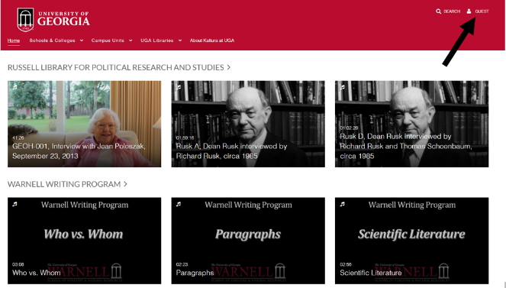
Click the Guest button in the upper right.
- Select Login
- This will take you to the CAS (Central Authentication Service) and you will login using your UGA MyID.

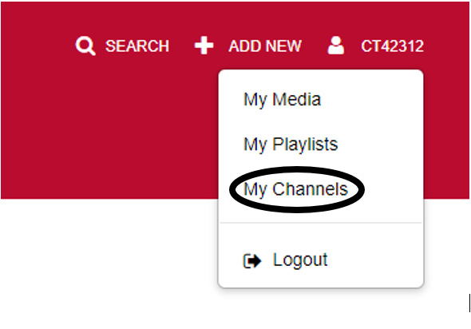
After logging in,
- click your login name
- choose My Channels to view your Kaltura channels

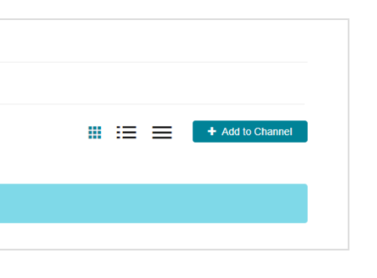
My Channels shows a list of the channels you manage.

Adding Media to a Channel

To add media to a channel, select the channel and click the Add to Channel dropdown menu and select which type you’d like to upload.
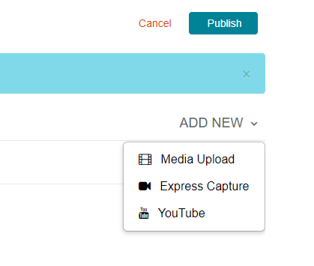
Click the Add New button and select the type of media you would like to upload. Choose Media Upload to upload a file from your device. You can also select to create a recording from a webcam or your screen.

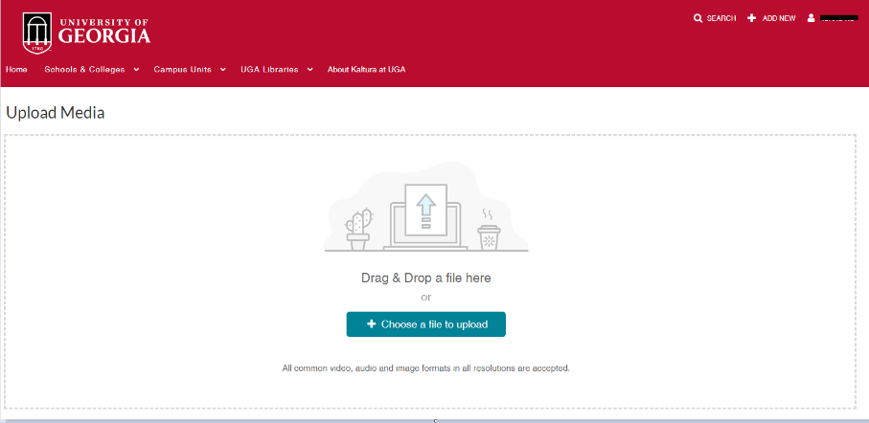
Click Choose a file to upload and select a media file. Kaltura supports most common video/audio/image formats.
Note: On a Windows-based PC, Zoom recordings are normally located in the Documents/Zoom folder and in a subfolder with the name of the event. The file that contains BOTH audio and video is called zoom_0.mp4. This is the file you will want to upload. You can also upload an audio only version – audio_only.m4a

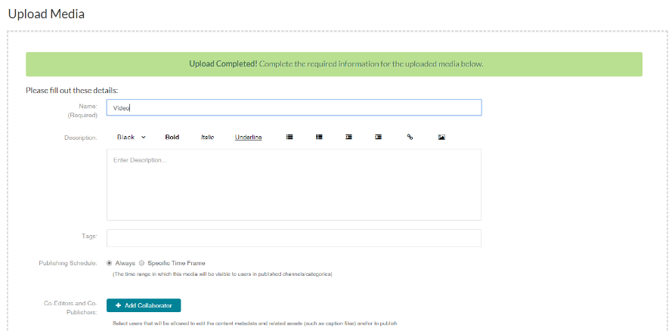
After the upload has completed, set a Name and Description for the video. You can also set Tags to categorize the video.
Note: It takes few minutes to process the video. After it’s completed processing, the media you uploaded can now be viewed in your channel
Click Save when done.
Click Go To Media to see your upload and to categorize.

Publishing your video for viewing

Click on the Action dropdown.
Choose Publish
Select how to publish your video

To Publish your video and make accessible via a link you can distribute, OIT recommends publishing as UNLISTED (if any of your viewers do not have UGA MYIDs, you must choose this option.)
- Private - Only the owner of the content can view the media
- Unlisted - Anyone with the link to the media page can view the media, including those without a UGA MyID.
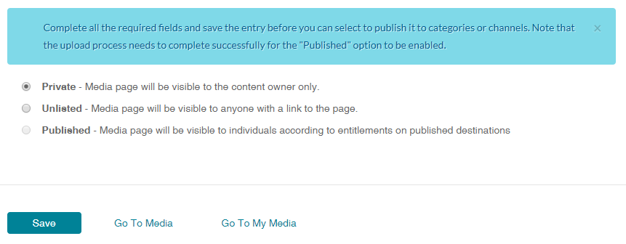
- Published - Check the channel(s) you want to add the media to. Only users who are members of the selected channel(s) will be able to view the media
Note: Choosing Unlisted will remove the media from any channels it was published in, but you can still access it from My Media.
Click Save. You will get a message that this action will un-publish the entry from all categories/channels. Are you sure you want to continue? Choose OK.

Sharing Media (generating a link to distribute)
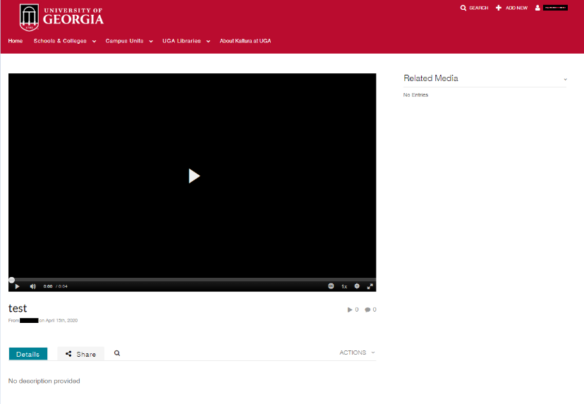
With your media displayed on the screen, Click the Share button to see options for sharing.
Choose Link to Media Page to get a link which you can copy and share with anyone.

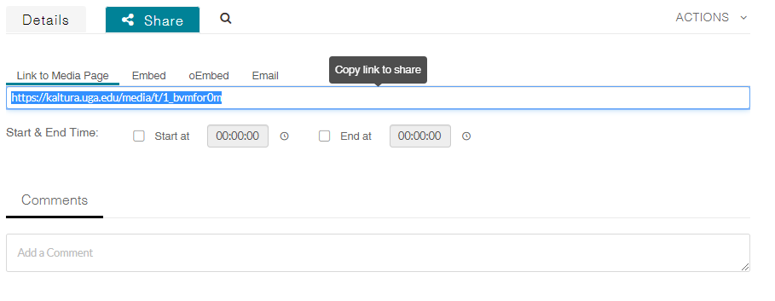
You can copy the link shown and paste it into an email to distribute to your viewing audience.

Upload a Captions File
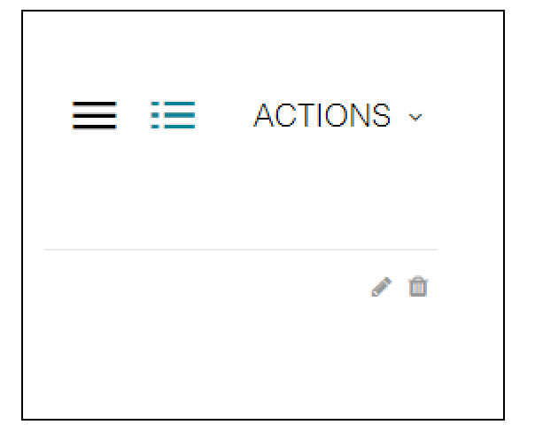
From Your Media, select Edit beside the video for which you want to upload a caption file.
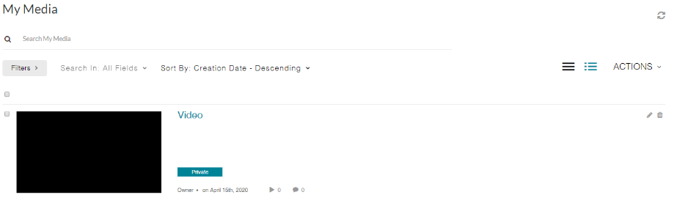

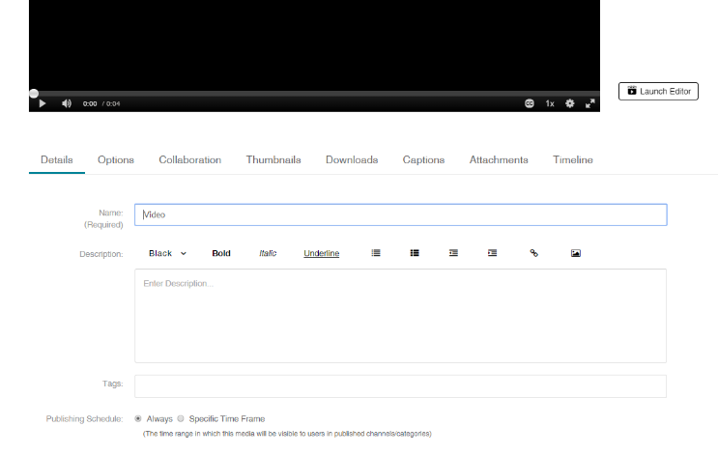
Select the Captions option underneath the video.
Then, select the blue Upload Captions File button which appears beneath.

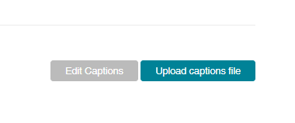
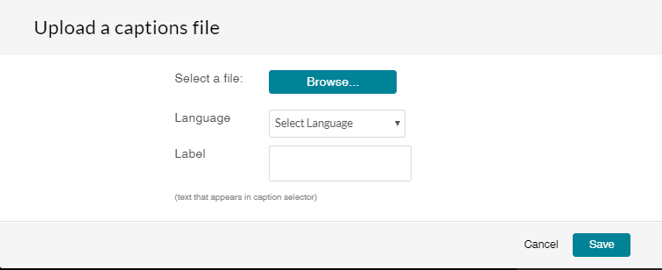
Select a caption file (SRT and DFXP formats are supported), then choose the Language of the captions and set a Label to be shown in the caption selector. After a caption file has been uploaded it can be searched from the search box below the media player.

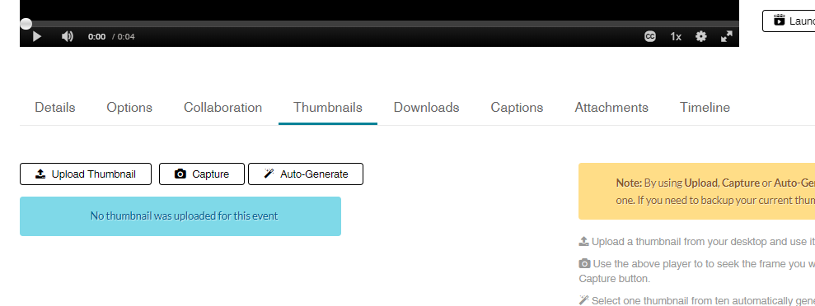
Thumbnail: Set the thumbnail to be shown for the media file.

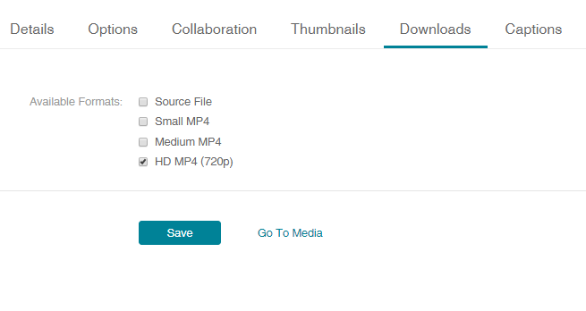
Downloads: Allow the media to be downloaded as the original file, small or medium MP4, and HD

Timeline: Set chapters and upload slides to play along with the video. 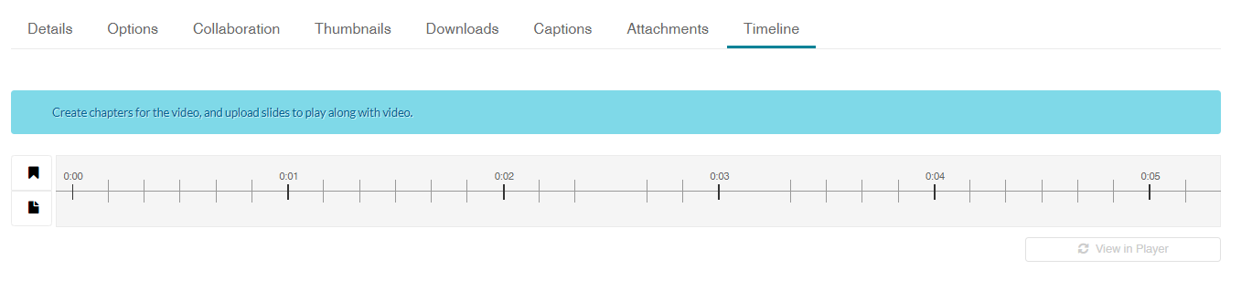

Managing Your Channel
You might want to add others to your channel so they can add/edit/ or distribute media from this same place.
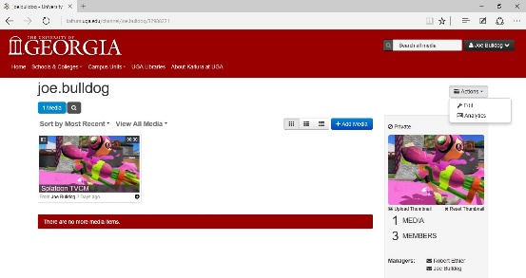
To manage your channel, go to the channel page, click the Actions button and choose Edit.

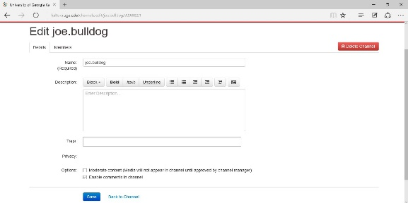
On the Details tab you can change the Name and Description of the channel, add Tags, and set options for moderation and comments.

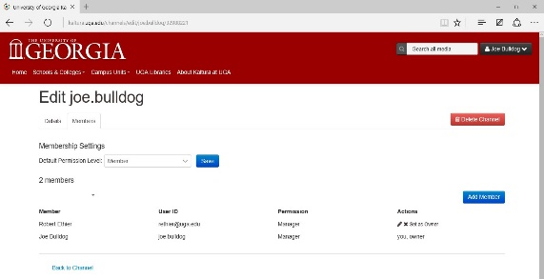
On the Members tab you can manage the members of your channel. To add a new member, click the Add Member button.

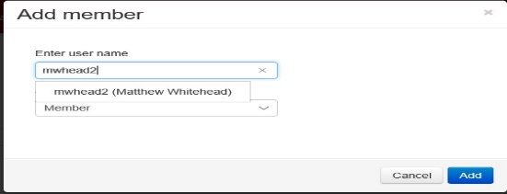
Enter the username of the person you would like to add and select them from the list.

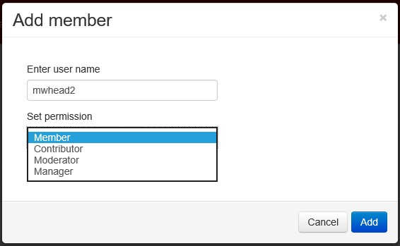
Choose the permissions you would like the member to have, then click Add:
- Member: Can view the channel and any media in it
- Contributor: Can view the channel and add media to it
- Moderator: Can view the channel, add media, and moderate
- Manager: Can view the channel, add media, moderate, and manage
You can view the channels you have been added as a member of by going to My Channels, clicking View channels I manage and selecting Channels I am a member of.

