Creating a myPass account with Alberta Education
What is myPass?
Go to https://mypass.alberta.ca/ to login or to create your myPass account. You will then see this screen:
If you already have a myPass account, click on the button “Sign in with an Education Account” and follow the login process.
If you do not have a myPass account, click on “First time to myPass? Sign in with an Education Account to connect to student information.”

Enter your personal email address (NOT your school email address) to sign up for myPass, and then click on “I’m new, sign me up!”. Then click on the “Sign Up” button at the bottom:
Your personal email goes here
Alberta Education will then email you a confirmation link. Go to your email to find this confirmation link:
Your personal email
Click on the confirmation link sent to your email.
This will then take you to a sign up page to setup your information. Once done, hit “Finish”:
Create a screen name
Your personal email

Click on the “No Access Code?” Request button to request an access code.
You will need to have your 9-digit Alberta Student Number (ASN) from your school to complete the next section. Please call or email your school if you do not have this information.
Once you have that information, enter your ASN and your Date of Birth, and click “Next”
Your birthdate goes here
Your 9-digit Alberta Student Number goes here
Click on Submit Connection Request at the bottom of the next page:

You will then be taken to this page:
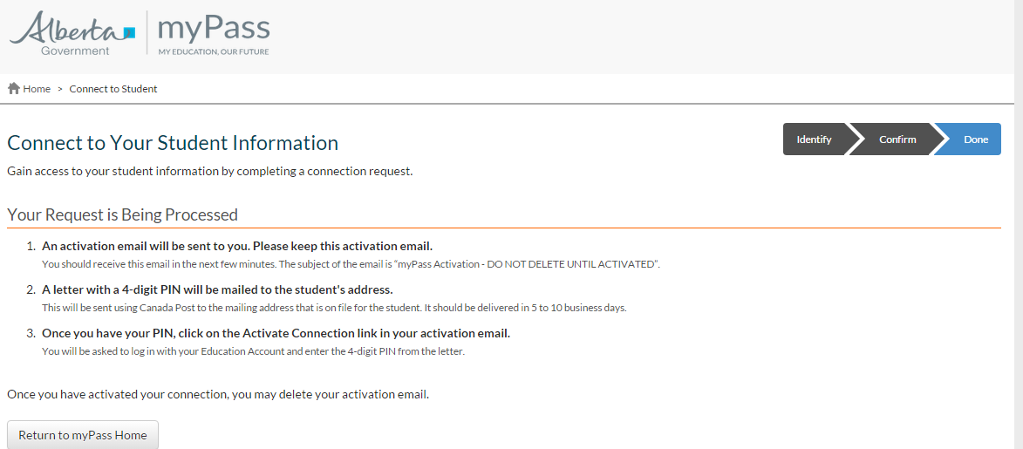
Please note that you will be sent an activation email. SAVE this activation email – do not delete it.
You will receive a letter in the mail with your 4-digit PIN.
Once you have your pin, click on the “Activate Connection” link in your email, and your myPass account will be created.

